ASSIGNMENT1: Setting Up Your Development Environment.

I am using windows 10 as my preferred operating system, which was already pre-installed.

Install Visual Studio Code

1. Download and Install VS Code:

- Went to https://code.visualstudio.com/Download).

- Downloaded and ran the installer.

- Followed the installation prompts to complete the setup.

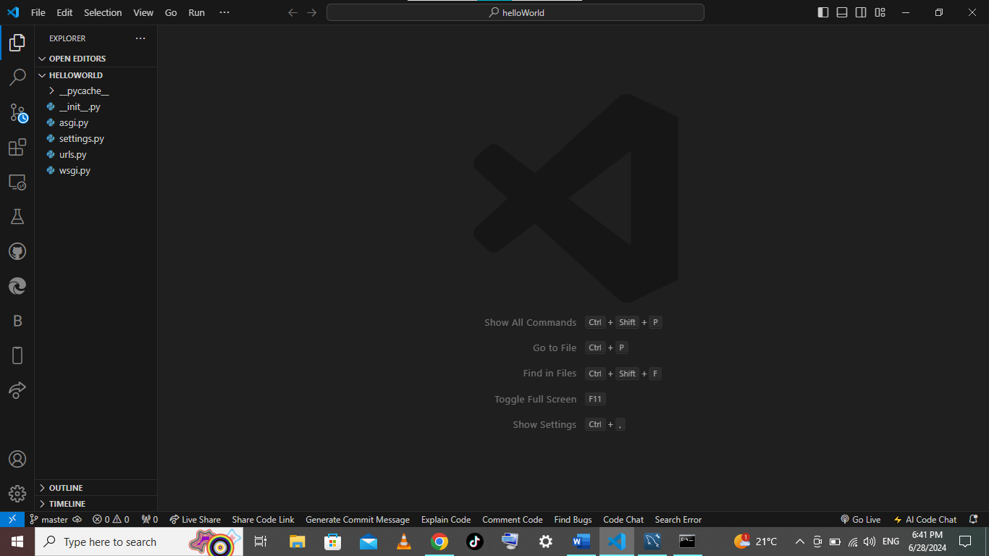

Install Python

1. Download and Install Python:

- Visited [http://www.python.org]

- Downloaded the latest version.

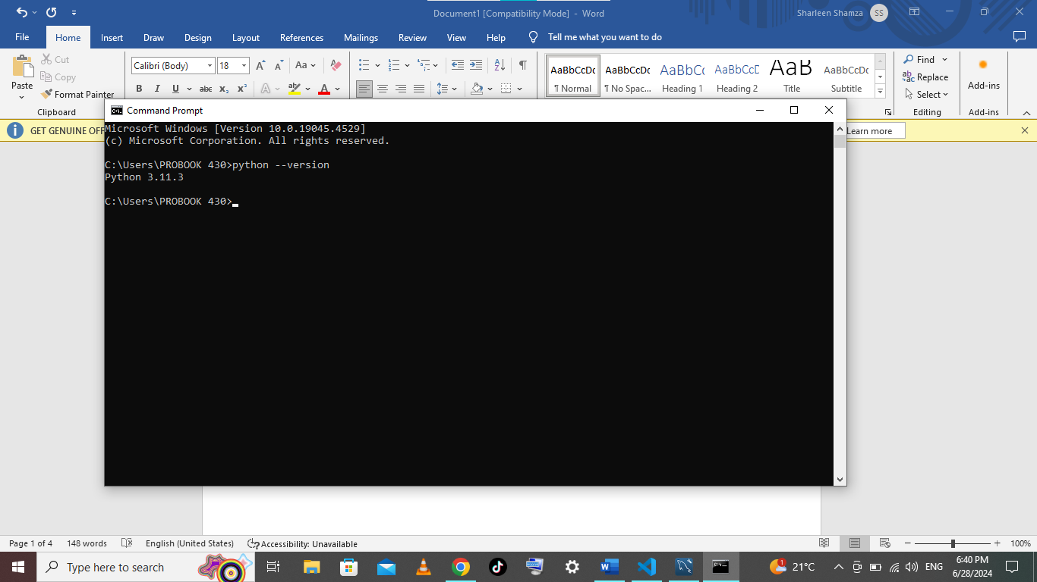

Install pip (Package Manager)

1. Verify pip Installation:

- Python typically includes pip. Verified by running `pip --version` in the command prompt.

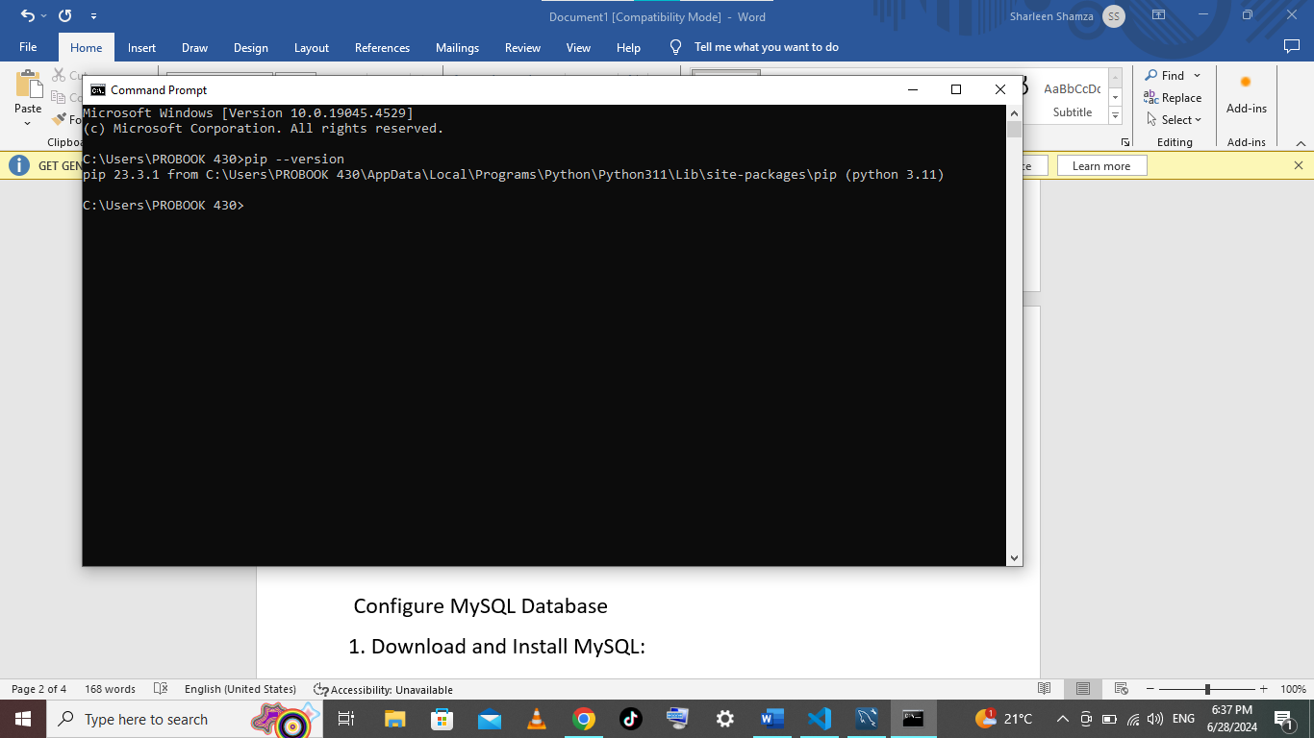

Configure MySQL Database

1. Download and Install MySQL:

- Went to https://dev.mysql.com/downloads/windows/installer/5.7.html).

- Downloaded and ran the MySQL Installer.

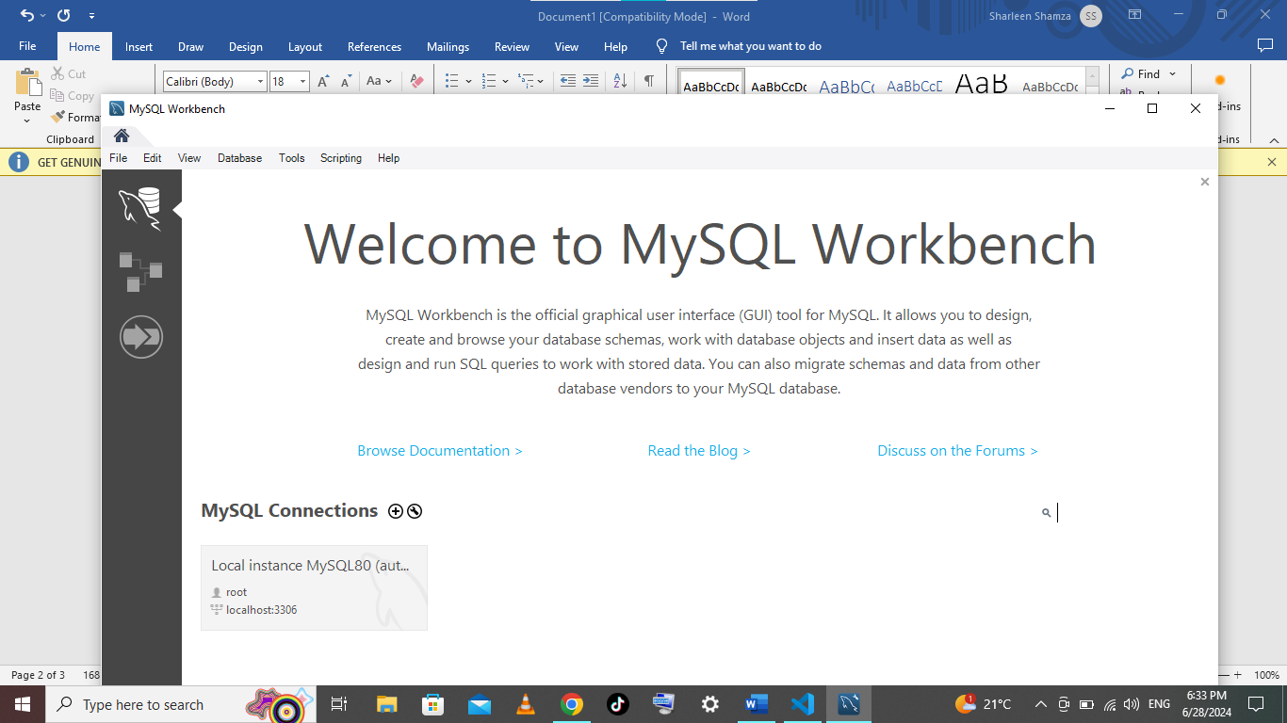

- Followed the setup wizard to install MySQL Server.

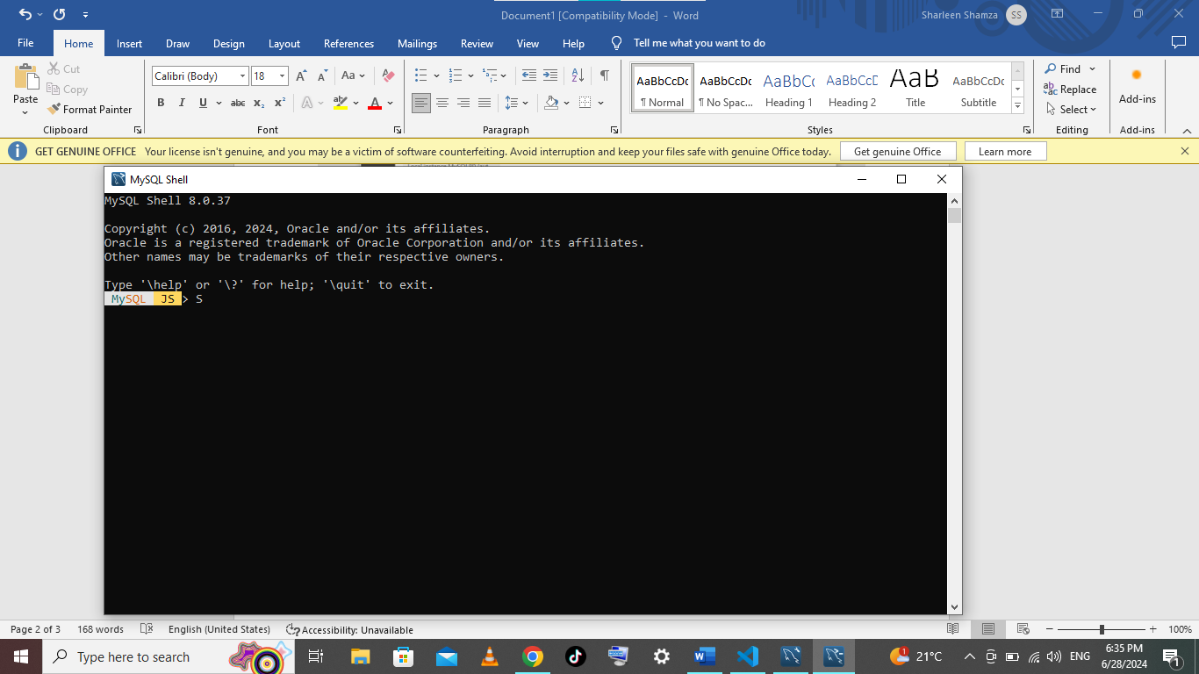

1. Install Extensions:

- Opened Visual Studio Code.

- I then navigated to Extensions view by clicking the Extensions icon.

- Searched for and installed useful extensions like Python, Prettier, Live Share, BlackBox AI etc.

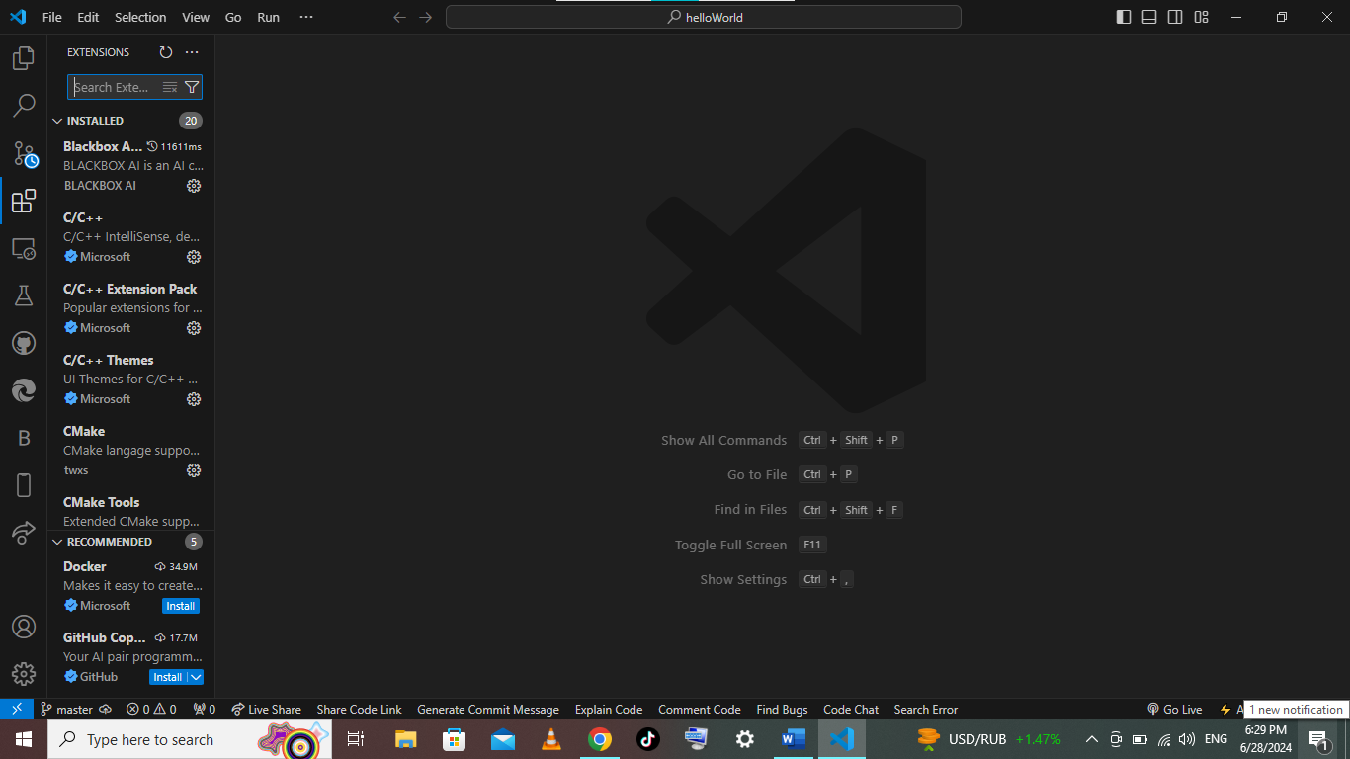

Install Git

1. Download Git:

- I visited (https://git-scm.com/) and clicked "Download" for Windows.

2. Install Git:

- I ran the downloaded installer and followed the prompts, keeping the default settings.

- I verified the installation by opening a command prompt and typing `git --version`.

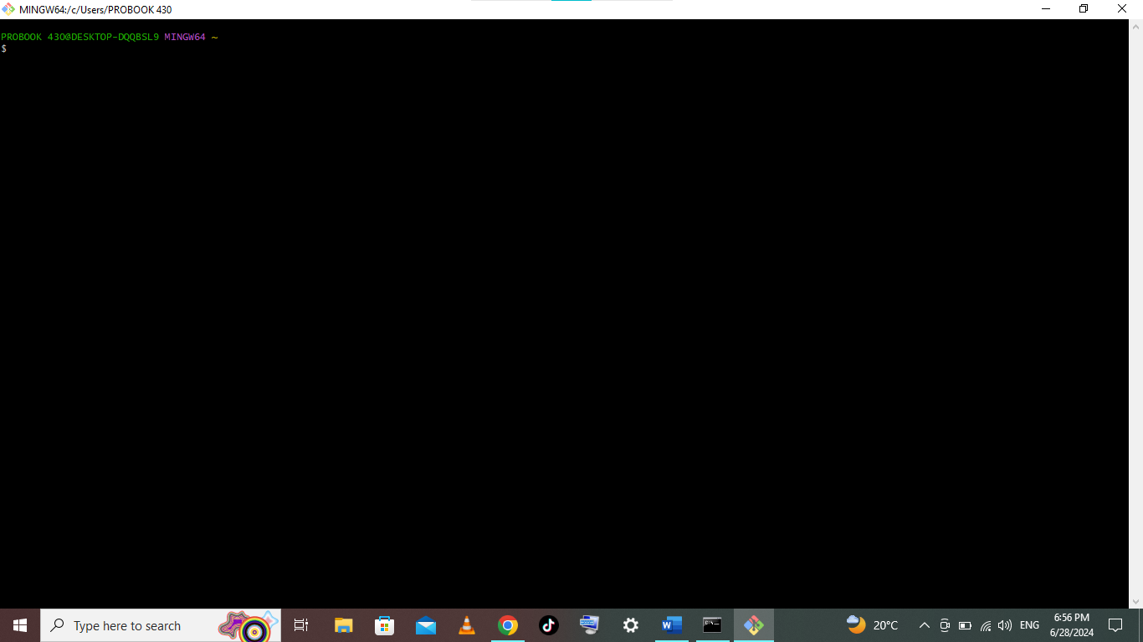

Set Up GitHub

1. Create a GitHub Account:

- I went to (https://github.com/) and signed up for a new account.

- I verified my email address.

Initialize a Git Repository and Connect to GitHub

1. Initialize a Repository:

- I opened Git Bash and navigated to my project directory with the `cd` command.

- I ran `git init` to initialize a repository.

2. Make the First Commit:

- I created a `README.md` file, staged it with `git add README.md`, and committed it with `git commit -m "Initial commit"`.

3. Create a Repository on GitHub:

- I clicked "New" on GitHub, filled out the repository details, and created it.

4. Connect and Push:

- I copied the repository URL, added the remote in Git Bash with `git remote add origin (repository-URL), and pushed with `git push -u origin master`.

